CSA1517
CLOUD COMPUTING AND BIG DATA ANALYTICS FOR HADOOP APPLICATIONS
P.DILLI BABU
192472284
EXP NO 2: CREATE A SIMPLE CLOUD SOFTWARE APPLICATION FOR FLIGHT RESERVATION SYSTEM USING ANY CLOUD SERVICE PROVIDER TO DEMONSTRATE SAAS.
DATE:
AIM: To create a simple cloud software application for flight reservation system using any cloud service provider to demonstrate saas.
PROCEDURE: step1: Go to zoho.com. step 2: Log into the zoho.com. step 3: Select one application step.
step4: Enter application name as flight reservation system. step 5: Created new application flight reservation system.
step 6: Select one form step 7: The software has been created.
OUTPUT:

STAFF
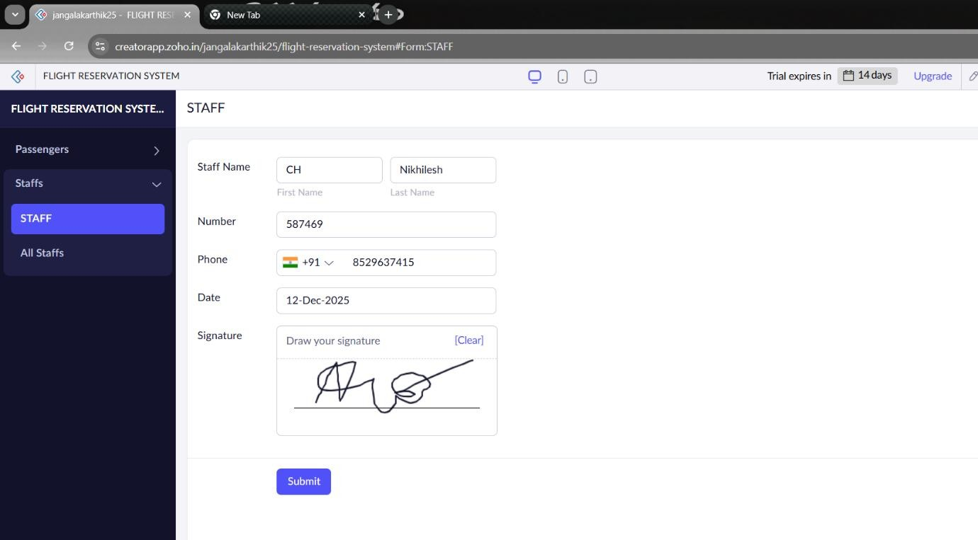
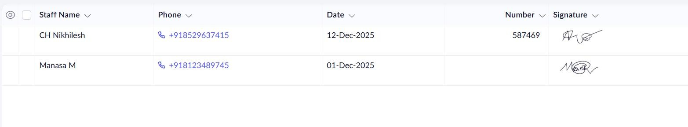

PASSENGER
